**Tracing the Growth of the Global Community: A Population Forecasting Analysis**



**DECLARATION**

I, Miss **POOJA.R (TEAM LEADER),** hereby declare that the project entitled **“DATA ANALYSIS AND VISUALIZATION USING TABLEAUFOR TRACNG THE GROWTH OF GLOBAL COMMUNITY : A POPULATION FORECASTING ANALYSIS”** submitted to **Bharathiar University**, in partial fulfillment of the requirements for the award of the degree of **BACHELOR OF SCIENCE IN MATHEMATICS WITH COMPUTER APPLICATIONS** is a report of original research work done by me during the period of study in **TIRUPPUR KUMARAN COLLEGE FOR WOMEN, TIRUPUR** under the guidance of **Mrs.S.MANONMANI,Assistant Professor, PG & Research Department of Mathematics ,** and I assure that this work has not been submitted to any other university for any other degree.

**PLACE:** TIRUPUR **Signature of the Candidate**

**DATE:19.04.2023**TEAM LEADER :

R.POOJA

TEAM MEMBERS :

M.CHANDRAMUGI

J.JEYA AKSHAYAA

V.NISHANTHINI

N.SHRIJAA

**SUBMITTED BY:**

**TIRUPPUR KUMARAN COLLEGE FOR WOMEN**

**PG & RESEARCH DEPARTMENT OF MATHEMATICS**

**III B.SC MATHEMATICS WITH COMPUTER APPLICATIONS**

|  |  |
| --- | --- |
| **TEAM ID** | **NM2023TMID11105** |
| **TEAM LEADER** | **1. R. POOJA** |
| **TEAM MEMBERS** | **2. M. CHANDRAMUGI** |
|  | **3. J. JEYA AKSHAYAA** |
|  | **4. V. NISHANTHINI** |
|  | **5. N. SHRIJAA** |
| **TEAM MENTOR** | **Mrs. S. MANONMANI** |

**TABLE OF CONTENT**

|  |  |  |
| --- | --- | --- |
| **CHAPTER NO.** | **CONTENT** | **PAGE NO.** |
| **I** | **INTRODUCTION**   * 1. **OVERVIEW**   2. **PURPOSE** | **1** |
| **II** | **PROBLEM DEFINITION AND DESIGN THINKING**  **2.1 PROBLEM DEFINING**  **2.2 EMPATHY MAP**  **2.3 BRAISTROMING MAP** | **2** |
| **III** | **RESULT**  **3.1 DATA COLLECTION, EXTRACTION & VISUALISATION**  **3.2 SQL**  **3.3 TABLEAU** | **8** |
| **IV** | **ADVANTAGES AND DISADVANTAGES**  **4.1 ADVANTAGES**  **4.2 DISADVANTAGES** | **16** |
| **V** | **APPLICATIONS**  **5.1 APPLICATIONS** | **18** |
| **VI** | **CONCLUSION**  **CONCLUSION**  **FUTURE ENHANCEMENT** | **19** |
| **VII** | **APPENDIX**  **LINKS** | **20** |

**TABLE OF CONTENT**

**1.INTRODUCTION**



* 1. **OVERVIEW**

The world population is more than three times larger than it was in the twentieth century. The global human population reached 8.0 billion in mid – November 2022 from an estimated 2.5 billion people in 1950, adding 1 billion people since 2010 and 2 billion since 1998. By nearly 2 billion persons in the text 30 years, from the current 8 billion in 2050 and could peak at nearly 10.4 billion in the mid-2080’s. This dramatic growth has been driven largely by increasing numbers of people surviving to reproductive age, the gradual increase in human lifespan, increasing urbanization and accelerating migration. Major changes in fertility rate have accompanied this growth. These trends will have far-reaching implications for generations to come.

* 1. **PURPOSE**

Population analysis is needed to identify problems and community needs, establish goals and objectives, assess alternative courses of action, allocate resources for plan implementation, and evaluate the ability of the plan to achieve goals and objectives. This method involves discovery of the factors that influence present and past population increase and decrease. On the basis of assumptions concerning the future of these factors, and of other factors that are just emerging in the community, projections of fertility, mortality and migration.

**2.PROBLEM DEFINING AND DESIGN THINKING**

**PROBLEM STATEMENT:**

The above introduction had an aim to increase the awareness about how the population forecasting analysis factors actually has an impact not only on the personal lives of the people, but also an impact on the world and its betterment. We will today have a look on the data extracted from the 2020 Census database from [www.kaggle.com](http://www.kaggle.com)and try to find the insights about how different features have an impact on the individual people. Though the data is quite old, and the insights drawn cannot be directly used for derivation in the modern world, but it would be surely help us to analyze what role different features play in the analysis.



**2**

**BUSINESS REQUIREMENT :**

The population of a country and its economic growth is closely interlinked with the attainment of economic development; a country must consider its human resources both from the angle of assets and liabilities. That proper utilization of natural endowments and the level of production of national wealth depend very much on the extent and efficiency of human resources, but too much of population will again eat up all the fruits of developments. From the point of view of economic welfare it is quite essential to study human resources in detail at the same time it should be stressed human beings are the vital instruments of production. The fruits of all economic activities are rested on the betterment of conditions of living of human being. The human resources are playing a vital role in attaining economic development of country. The economic development of country involves proper utilization of its physical resources by its labor force and other forms of man power, thus it involves achievement of 3 conditions.

* An increase in the per capita income to raise the level of living of the people.
* A fall in the magnitude and rate of unemployment.
* A consequent reduction is the number of people lying below poverty line.

**“ POPULATION GROWTH AS A SOURCE OF ECONOMIC DEVELOPMENT “**

The growing population can definitely stimulate the economic growth under the three following conditions;

* If the labor supply is scarce in relation to natural and capital resources of the country.
* If the economy can flourish in the world trade
* If the social attitudes are in favor of turning hardships into opportunities.
* Increase in Investment.
* Raising population and growing Talents.
* Increasing in demand and supply.
* Increasing military power.

**3**

**LITERATURE SURVEY :**

For this review, we searched for journal papers, book chapters, and reports which

(i) Contained details on forecasting methods and approaches

(ii) Were for small areas, and

(iii) Were published between 1st January 2001 and 31st December 2020.

We included literature which focused on forecasting the components which directly feed into small area population forecasts, such as fertility, mortality, and migration rates. We also included methods for quantifying the uncertainty of small area population forecasts. Our approach to searching the literature on small area population forecasting methods made use of several information sources. First, we searched for paper son Google Scholar using Harzing’s Publish or Perish (as it allows search results to be exported Harzing, 2007), JSTOR, Scopus, Web of Science, Springer, Emerald, Wiley, Gale, PubMed, and the arXiv preprint server. Search terms used were population projection, population forecast, population prediction; small area, local area, grid square, gridded, spatial, sub national population, sub-regional population, small area population, ward-level population, county-level population, population project population ,and population forecast and additional terms used to find articles on estimating the components of small area population projections included age-specific migration, age-specific mortality, age-specific fertility, fertility, age profile, estimating, and estimation. Second, we followed up references in selected papers which appeared to focus on small area population forecasts. Third, we added our own papers on small area forecasting which we have collected over the years. We created an annotated bibliography and drafted a brief summary of up to 100 words of the main points for each of the selected papers. Finally, we approached the corresponding authors of these papers and asked them to check over our draft summaries and correct them if necessary. We also asked if there were any other papers within the scope of the review which we may have missed. A total of 51 authors were contacted and 20 summaries were revised. Following consultations with the authors, a further 6 papers were added to the review and summarized in the annotated bibliography. The final total number of papers included in the review is 84.

**4**

**REFERENCES:**

* Alexander, M. Zagheni, E., & Barbieri, M. (2017). A fexible Bayesian model for estimating subnationalmortality. Demography, 54(6), 2025–2041. <https://doi.org/10.1007/s13524-017-0618-7>
* Alho, J. M. (2015). Population forecasts. In J.D. Wright (Ed.), International encyclopedia of the social &behavioral sciences (2nd ed., pp. 593–596). Elsevier.Alkema, L., & New, J. R. (2014). Global estimation of child mortality using a Bayesian B-spline biasreduction model. The Annals of Applied Statistics, 8(4), 2122–2149.

<https://doi.org/10.1214/14-AOAS768>

* Alkema, L., Raftery, A. E., Gerland, P., Clark, S. J., Pelletier, F., Buettner, T., & Heilig, G. K. (2011). Probabilistic projections of the total fertility rate for all countries. Demography, 48(3), 815–839

.<https://doi.org/10.1007/s13524-011-0040-5>

* Alonso Gonzalez, M. L., Fernandez Vazquez, E., &Rubiera Morollon, F. (2015). A methodological note for local demographic projections: A shift-share analysis to disaggregate official aggregated estimations. Revista Electronica de Comunicaciones Trabajos de Asepuma, 16(1), 43–50.
* Anson, J. (2018). Estimating local mortality tables for small areas: An application using Belgiansubarrondissements.QueteletJournal,6(1),73–97. <https://doi.org/10.14428/rqj2018.06.01.04>

**5**

**SOCIAL IMPACT :**

People must be physically, socially and mentally healthy for the development of any nation. Growing population brings changes in social values and beliefs, cultural behavior, traditions and customs of the society. Rapid population growth leads to more production of goods due to the available labor, increasing tax revenue. This increased tax revenue can be used on environmental and health projects. The economy can benefit from economies of scale and increased specialization. Population growth can also improve per capita incomes. As the population increases, the economy can benefit from a bigger talent pool, economies of scale and greater specialization. All this can enable higher per capita income, which we have seen in major developed economies.

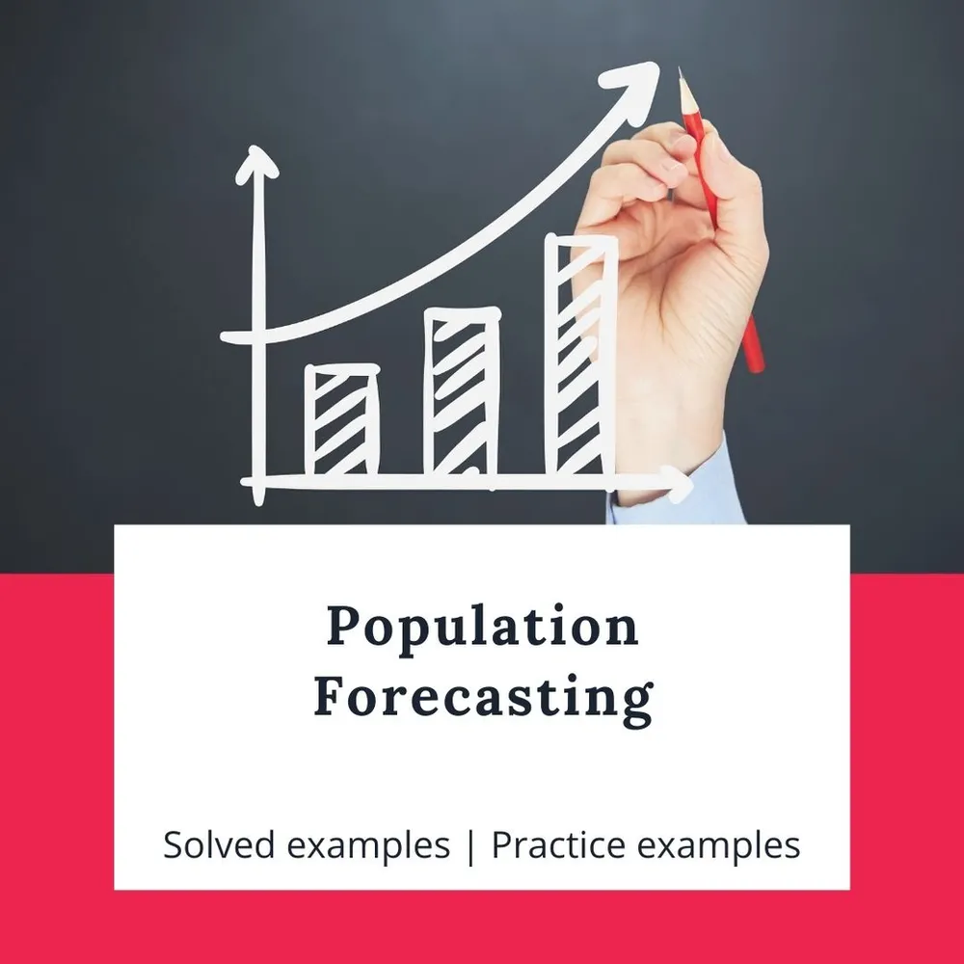

**6**

**2.2 EMPATHY MAP**

**https://drive.google.com/file/d/1ikgqGzXv1qYjo5fG0e_I0glSxXbCVS_/view?usp=drivesdk**

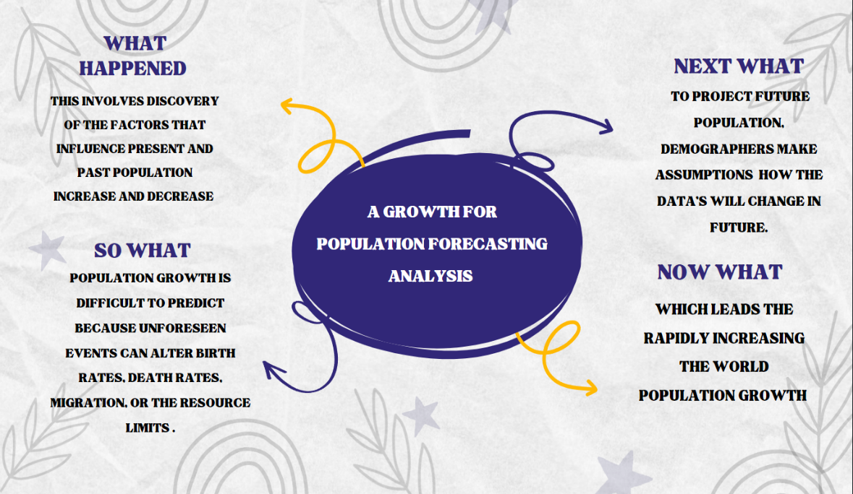

**2.3 BRAINSTORMING MAP:**

**A POPULATION FORECASTING ANAYSIS**

[**https://drive.google.com/file/d/1jLtwYXF3rdzT5p9fWrkC0CV954RpaojU/view?usp=drivesdk**](https://drive.google.com/file/d/1jLtwYXF3rdzT5p9fWrkC0CV954RpaojU/view?usp=drivesdk)

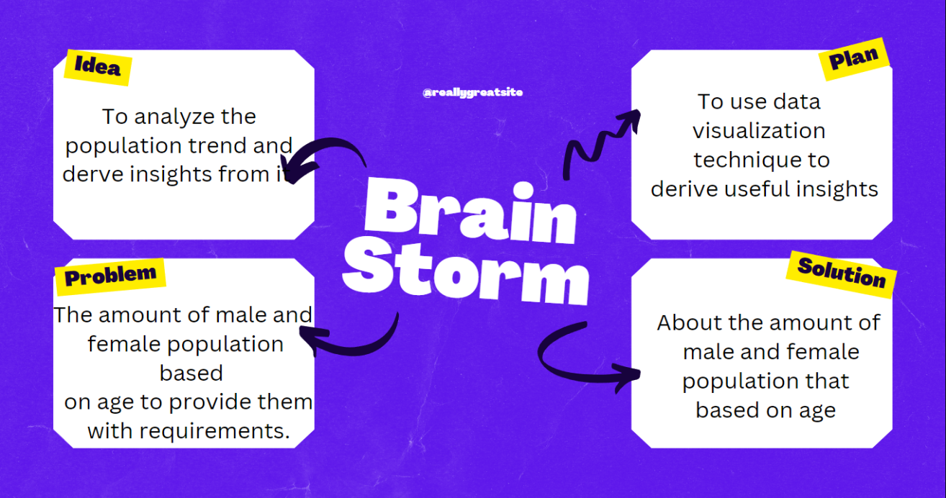

**7**

**3.RESULT**

**3.1 DATA COLLECTION, DATA EXTACTION & DATA VISULIZATION**

**DATASET**

* [**https://drive.google.com/file/d/18Hwt170ltNPxV_ZFcFGylxKLUS8IdnSo/view?usp=drivesdk**](https://drive.google.com/file/d/18Hwt170ltNPxV_ZFcFGylxKLUS8IdnSo/view?usp=drivesdk)

**UNDERSTANDING THE DATA:**

In dataset consumption .csv data in the form of a World population by age 2020. The Column of the dataset contains:

* Location
* Age group
* Male population
* Female population
* Total population

**STORING DATA IN DB & SQL OPERATIONS:**

**SQL**

**CREATING SCHEMA:**

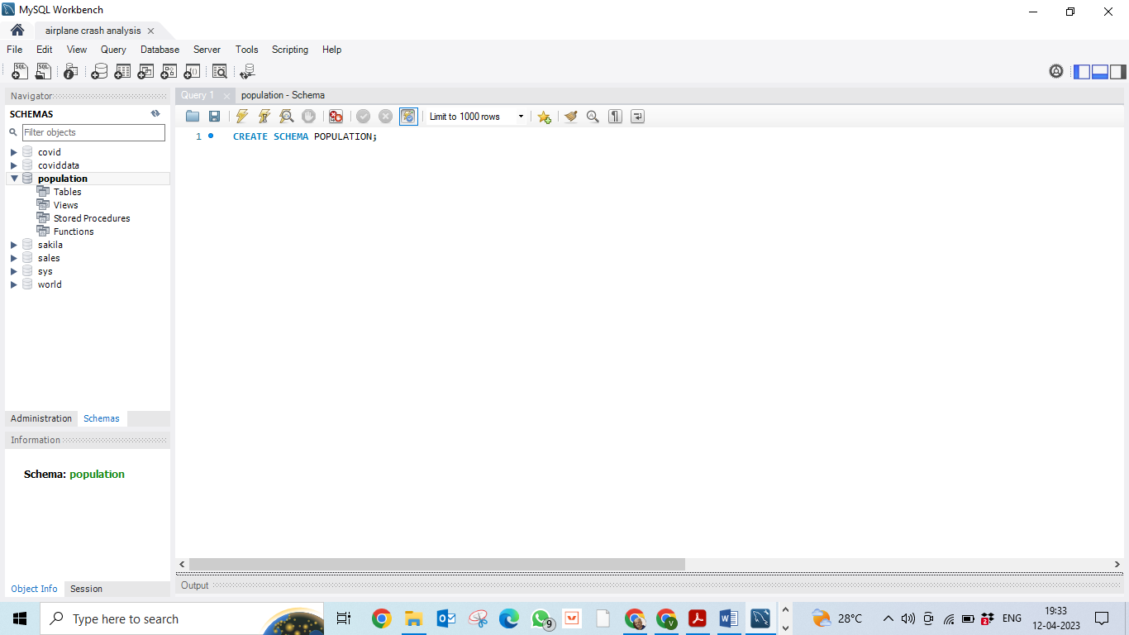

8

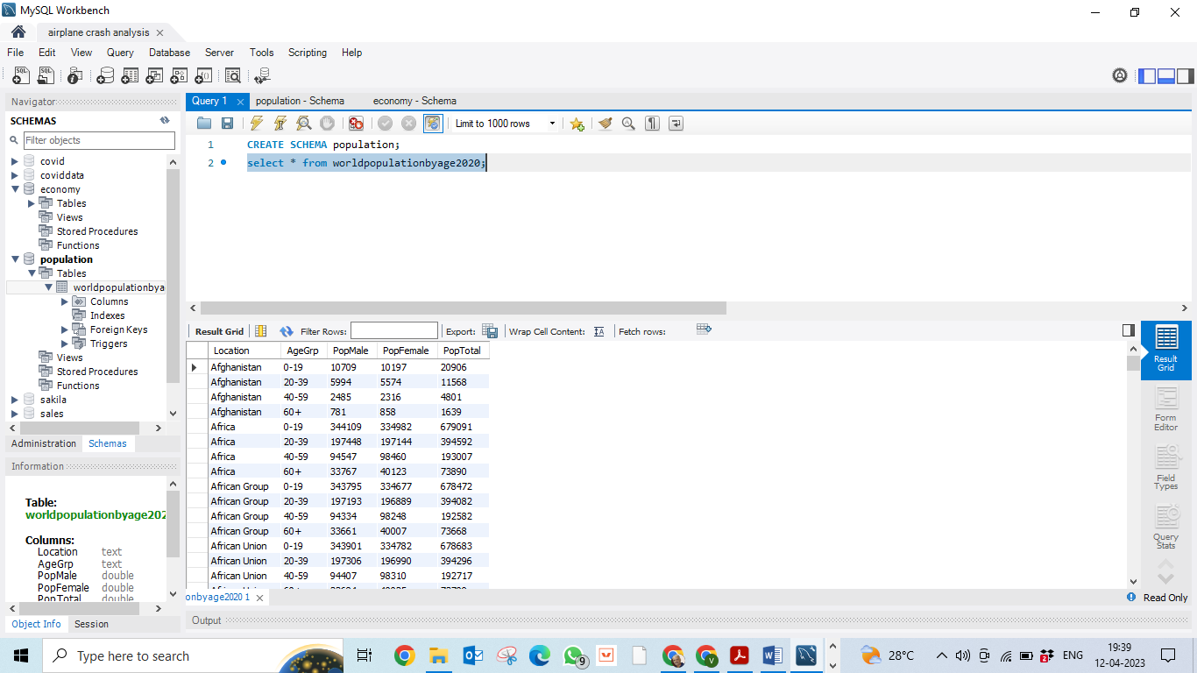

**VIEWING TABLE:**

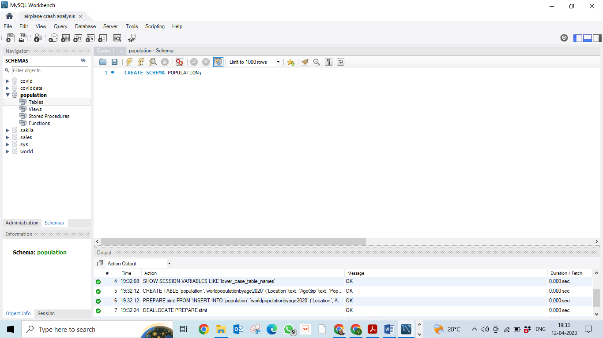

**9**

**TABLEAU:**

**INSTALLATION**

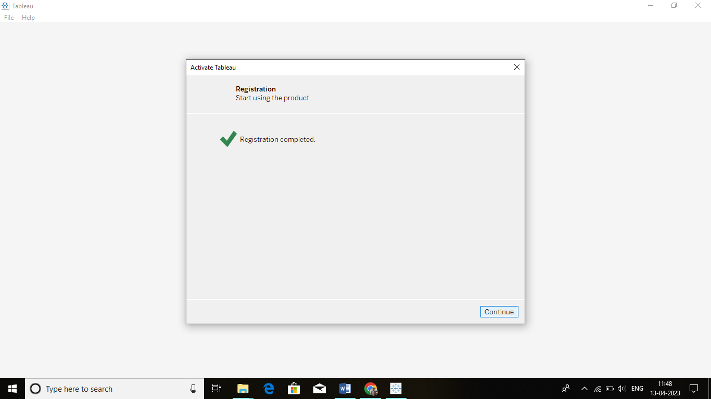

**DEFAULT WINDOW:**

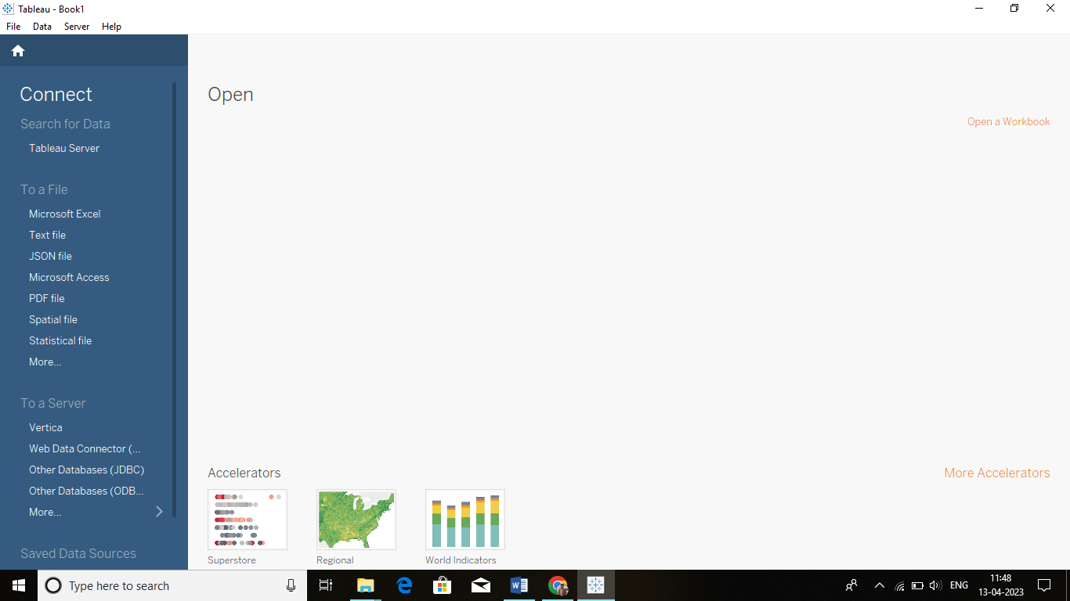

**10**

**DATA VISUALISATION**

**LOADING THE DB WITH TABLEAU:**

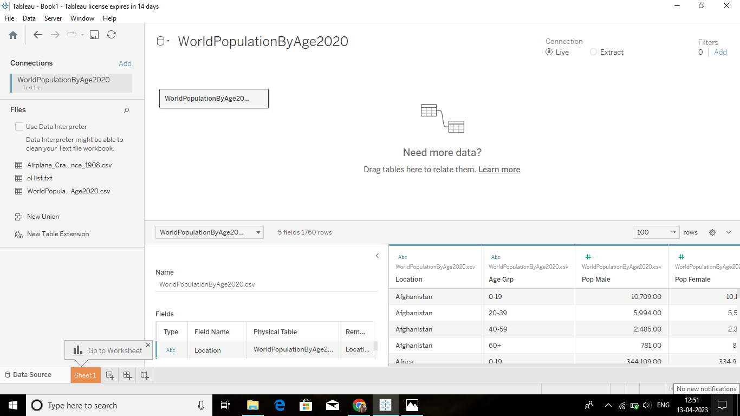

[**https://drive.google.com/file/d/1QCUrPtcGd6lJwNt9vuryxHfrN3TPoitI/view?usp=drivesdk**](https://drive.google.com/file/d/1QCUrPtcGd6lJwNt9vuryxHfrN3TPoitI/view?usp=drivesdk)

**11**

**TOTAL POPULATION BY AGE GROUP**

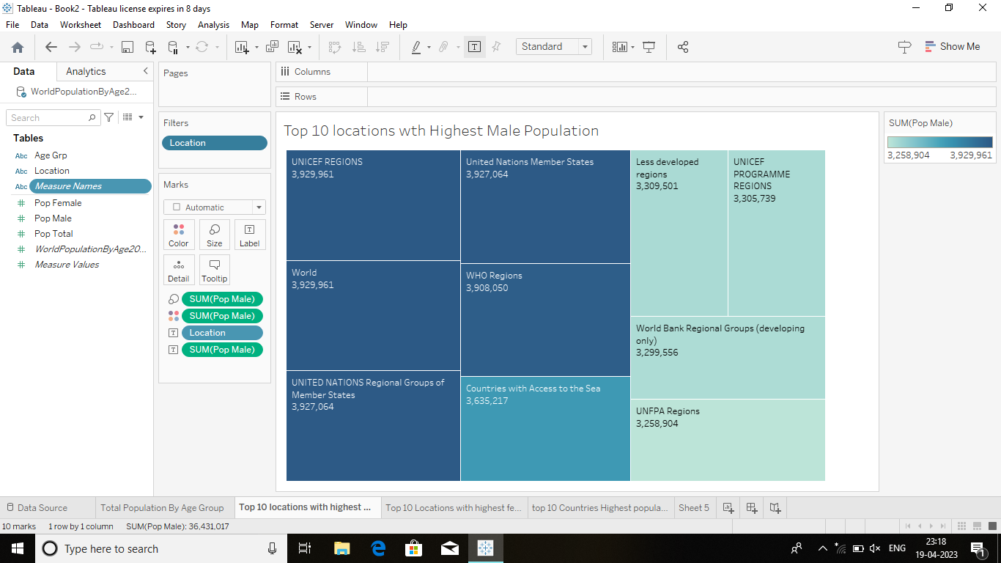

**TOP 10 LOCATIONS WITH HIGHEST MALE POPULATION :**

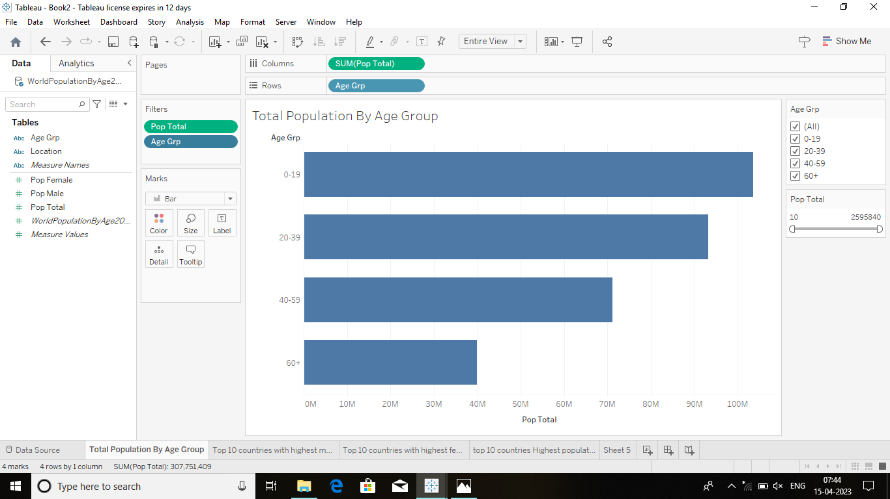

**12**

**TOP 10 LOCATIONS WITH HIGHEST FEMALE POPULATION :**

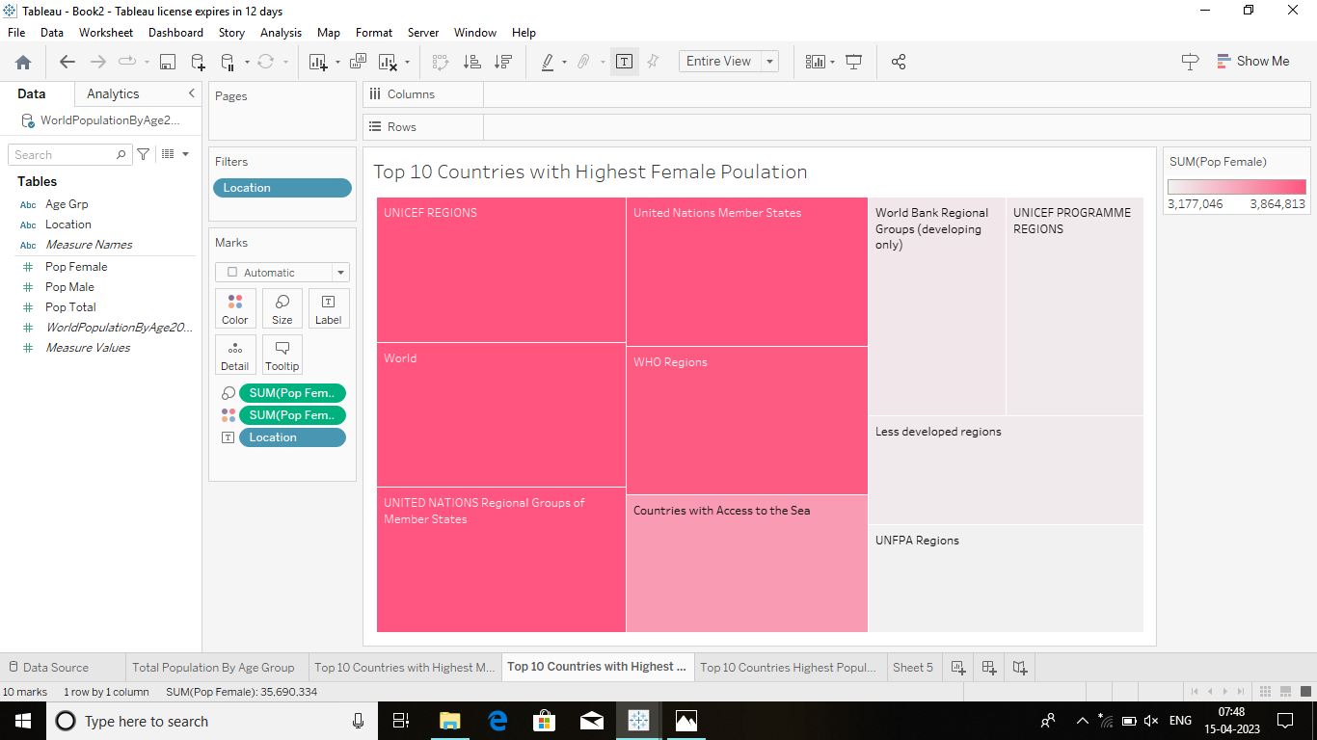

**TOP 10 COUNTRIES WITH HIGHEST POPULATION :**

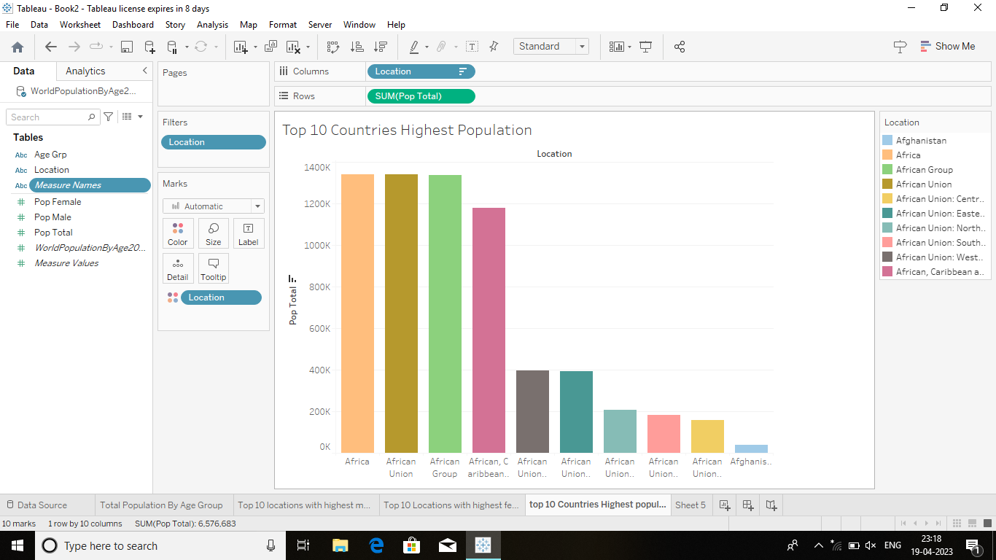

**13**

**TABLEAU DASHBOARD:**

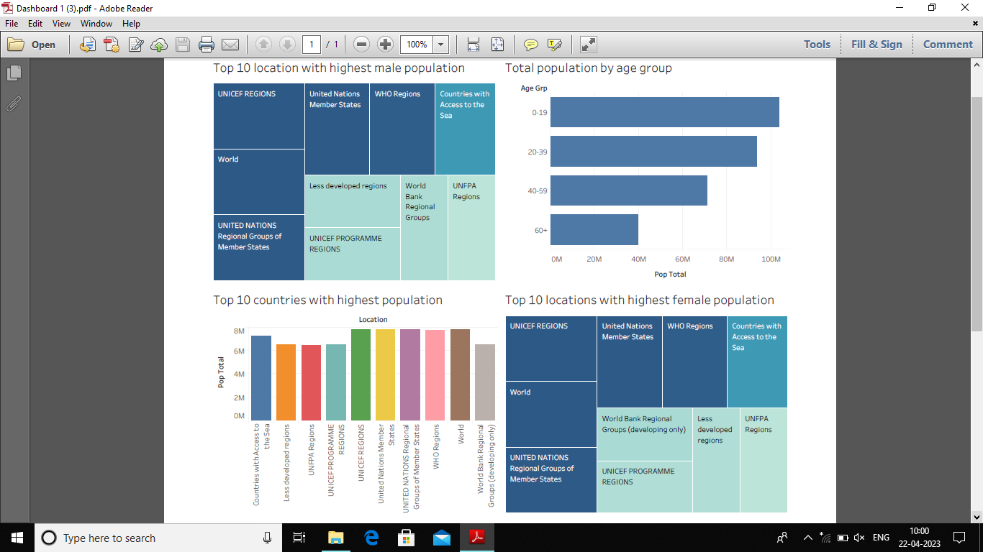

[**https://drive.google.com/file/d/16tZc4QzsdaqzC7URkrd1soGkfdG95VAg/view?usp=share_link**](https://drive.google.com/file/d/16tZc4QzsdaqzC7URkrd1soGkfdG95VAg/view?usp=share_link)

**TABLEAU STORY:**

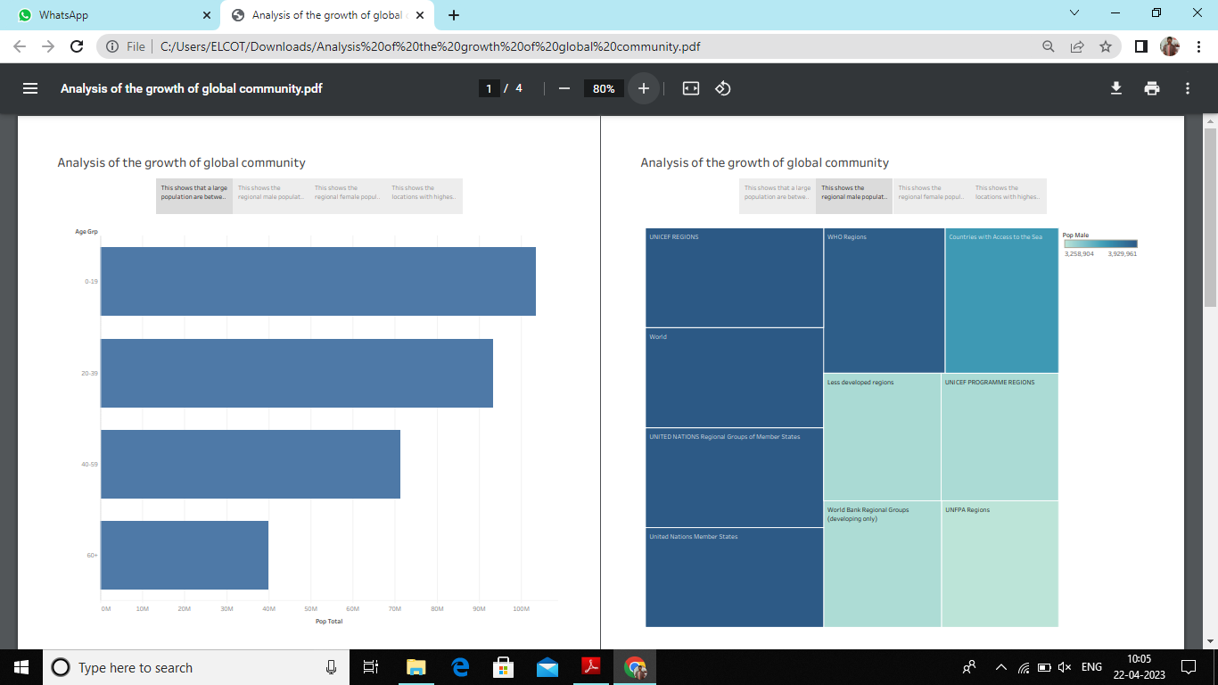

**14**

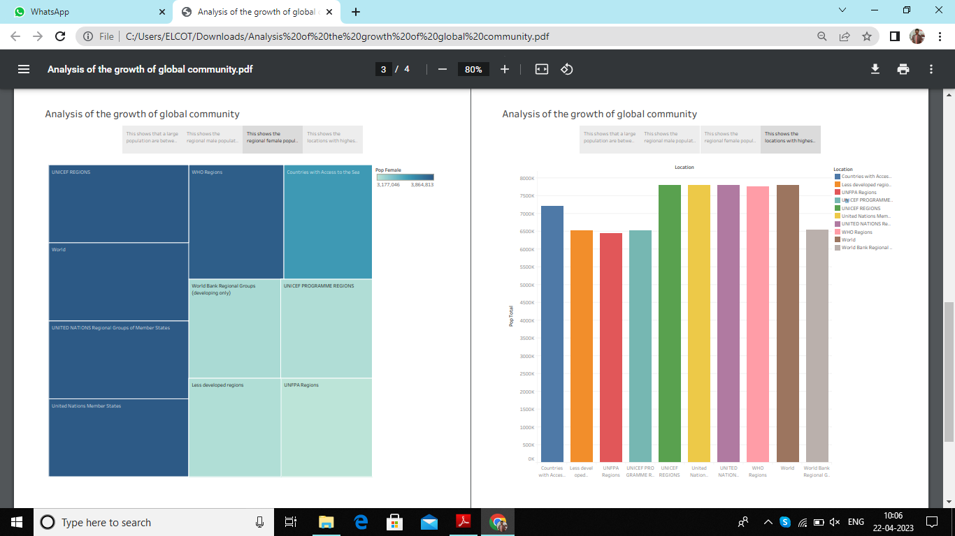

[**https://drive.google.com/file/d/1vkMFs08TKSwnbuAfwxFkr8BgXQ0GJVa/view?usp=share_link**](%20%20%20%20%20%20%20https://drive.google.com/file/d/1vkMFs08TKSwnbuAfwxFkr8BgXQ0GJVa/view?usp=share_link)

**15**

**4.ADVANTAGES AND DISADVANTAGES**

**4.1 ADVANTAGES:**

A Reliable regional population forecasting can provide important information for urban planning, especially for decision support in regional planning. Basically, the analysis of regional population forecasting can be applied to estimate the demand of land for residents, industries, public facilities, and so on. In general, the scale of population has determined the demand for land, public infrastructure, and urban services. Meanwhile, it also determines the demand for natural resources and hence may have a negative impact on the natural environment, and the development process in a densely populated area is sometimes restricted in accordance with the carrying capacity. Thus, how to accurately estimate population growth in the near future has become an issue for the pioneering work of urban planning.

Population projection is important since it helps people i.e. government, researchers, make decisions about the future.

Here are some possible ways that people use the result of population projection.

1. Estimate the basic need for human, such as demand for food, water, power, transportations.

2. Plan constructions such as housing, highways etc.

3. Estimate the labor forces in various places.

4. Estimate the potential consumptions in various regions.

5. Benefit sociological research, such as providing data about sex ratio or age ratio.

**16**

**4.2 DISADVANTAGES:**

Population projections, like some other types of projections, may indicate that existing trends and policies are likely to lead to outcomes which are judged undesirable. If new policies are then introduced, they may result in the original projections not being realised. However, this means the projections will have fulfilled one of their prime functions, to show the consequences of present demographic trends with sufficient notice for any necessary action to be taken.

Development plans may be based on reasoned and agreed departures from the projections if they seem better placed to fit particular local circumstances.

The reliability of population projections decreases over time, and projections tend to be less reliable in periods of rapid change. Projections for areas with small populations tend to be less reliable than those for areas with large populations.

* Population forecasts try to estimate the rate of population growth. However unpredictable factors can change fertility rates, mortality rates, or migration rates, which can cause difficulty in forecasting.
* Population Forecasts are never completely accurate.
* More people increased demand for the food, water, housing, energy, healthcare, transportation and more. And that consumption contributes to ecological degradation, increased conflicts, and a higher risk of largescale disasters. So it is difficult to predict the future assumptions.
* There is a greater risk to manage the data.
* Migration tends to fluctuate more than fertility or mortality and it is harder to measure. so there tends to be more uncertainty around migration figures.

**17**

**5. APPLICATIONS**

**5.1 APPLICATIONS:**

* It is important to have high quality statistics on the population and projections of the population, for policy development and for planning and providing public services.

Thei ruses include:

* Central and local finance allocation.
* Informing local and national policy.
* Childcare and schools planning.
* Housing and land use planning.
* Health care planning.
* Modelling and projecting health care indicators.
* Weighting surveys.
* Benchmarking other projections and as a control for smaller area projections.
* Looking at the implications of an ageing population.
* Making national and international comparisons.

**18**

**6.CONCLUSION**

**CONCLUSION :**

Population projections, like master plans, must be revised quite frequently. It has been suggested in this report that several alternative projections be made on the basis of different sets of assumptions. There is no easy method to analyze the population forecasting. Some demographers feel that fertility and mortality rates are nearing some sort of stability. Should this actually happen, a series of formulae might be developed by which fertility and mortality might be projected, leaving migration as the field for most intensive scrutiny. The "stability" does not yet exist. Given though the planner of today must resort to "enlightened guesses", he must be aware of the many complex interacting forces that influence future population numbers, composition and place of residence.

**FUTURE ENHANCEMENT :**

To improve population forecasting in the future, demographers should conduct more thorough assessments of the accuracy of past projections. Re- search should also focus on making greater use of : models that include marriage, divorce, cohabitation, morbidity, and other demographic events that influence fertility, mortality, and migration as well as models that break populations down by educational achievement, employment status, and other variables; models that take account of economic, social, and environmental dynamics, including integrated structural models and models with constraints; and forecasting approaches that systematically quantify uncertainty. A further area that requires rethinking is the appropriate use of expert judgment in population projections. Finally, new ways need to be developed for distributing software for making population forecasts and for disseminating the results of alternative forecasts

**19**

**7.APPENDIX**

**LINKS**

* **DATA SET:**

[**https://drive.google.com/file/d/18Hwt170ltNPxV_ZFcFGylxKLUS8IdnSo/view?usp=drivesdk**](https://drive.google.com/file/d/18Hwt170ltNPxV_ZFcFGylxKLUS8IdnSo/view?usp=drivesdk)

* **EMPATHY MAP:**

**https://drive.google.com/file/d/1ikgqGzXv1qYjo5fG0e_I0glSxXbCVS_/view?usp=drivesdk**

* **BRAINSTORMING MAP:**

[**https://drive.google.com/file/d/1jLtwYXF3rdzT5p9fWrkC0CV954RpaojU/view?usp=drivesdk**](https://drive.google.com/file/d/1jLtwYXF3rdzT5p9fWrkC0CV954RpaojU/view?usp=drivesdk)

* **TABLEAU WORKBOOK :**

[**https://drive.google.com/file/d/1QCUrPtcGd6lJwNt9vuryxHfrN3TPoitI/view?usp=drivesdk**](https://drive.google.com/file/d/1QCUrPtcGd6lJwNt9vuryxHfrN3TPoitI/view?usp=drivesdk)

**https://drive.google.com/file/d/15W37kLHyAL7mhSHrHwokCHQx0WgIYnip/view?usp=share_link**

* **TABLEAU PROJECT ILLUSTRATION VIDEO:**

[**https://drive.google.com/file/d/1mFMvRVI3p5v4Sf_DCjMkndFw7NuXcy5D/view?usp=drivesdk**](https://drive.google.com/file/d/1mFMvRVI3p5v4Sf_DCjMkndFw7NuXcy5D/view?usp=drivesdk)

* **TABLEAU DASHBOARD:**

[**https://drive.google.com/file/d/16tZc4QzsdaqzC7URkrd1soGkfdG95VAg/view?usp=share_link**](https://drive.google.com/file/d/16tZc4QzsdaqzC7URkrd1soGkfdG95VAg/view?usp=share_link)

**20**

* **TABLEAU STORY :** [**https://drive.google.com/file/d/1vkMFs08TKSwnbuAfwxFkr8BgXQ0GJVa/view?usp=share_link**](%20%20%20%20%20%20%20https://drive.google.com/file/d/1vkMFs08TKSwnbuAfwxFkr8BgXQ0GJVa/view?usp=share_link)

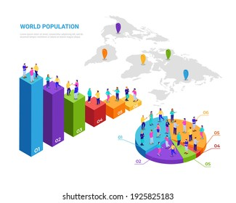

**21**

